Amazon Rekognition Features

# Steps to Use Amazon Rekognition

1. Sign in to the AWS Management Console.

2. Navigate to the Amazon Rekognition service.

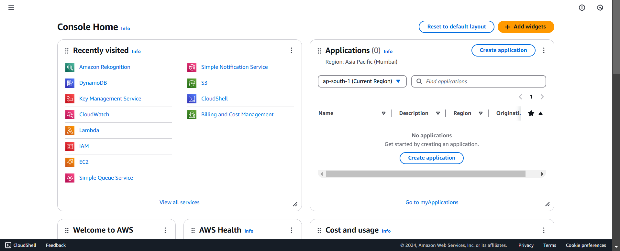

# 

# 1. Label Detection

Amazon Rekognition can identify objects, scenes, and activities in images, and videos. It assigns labels to detected objects such as people, animals, or vehicles. This helps in automating the process of identifying content in media.( upload or paste the link of image.)

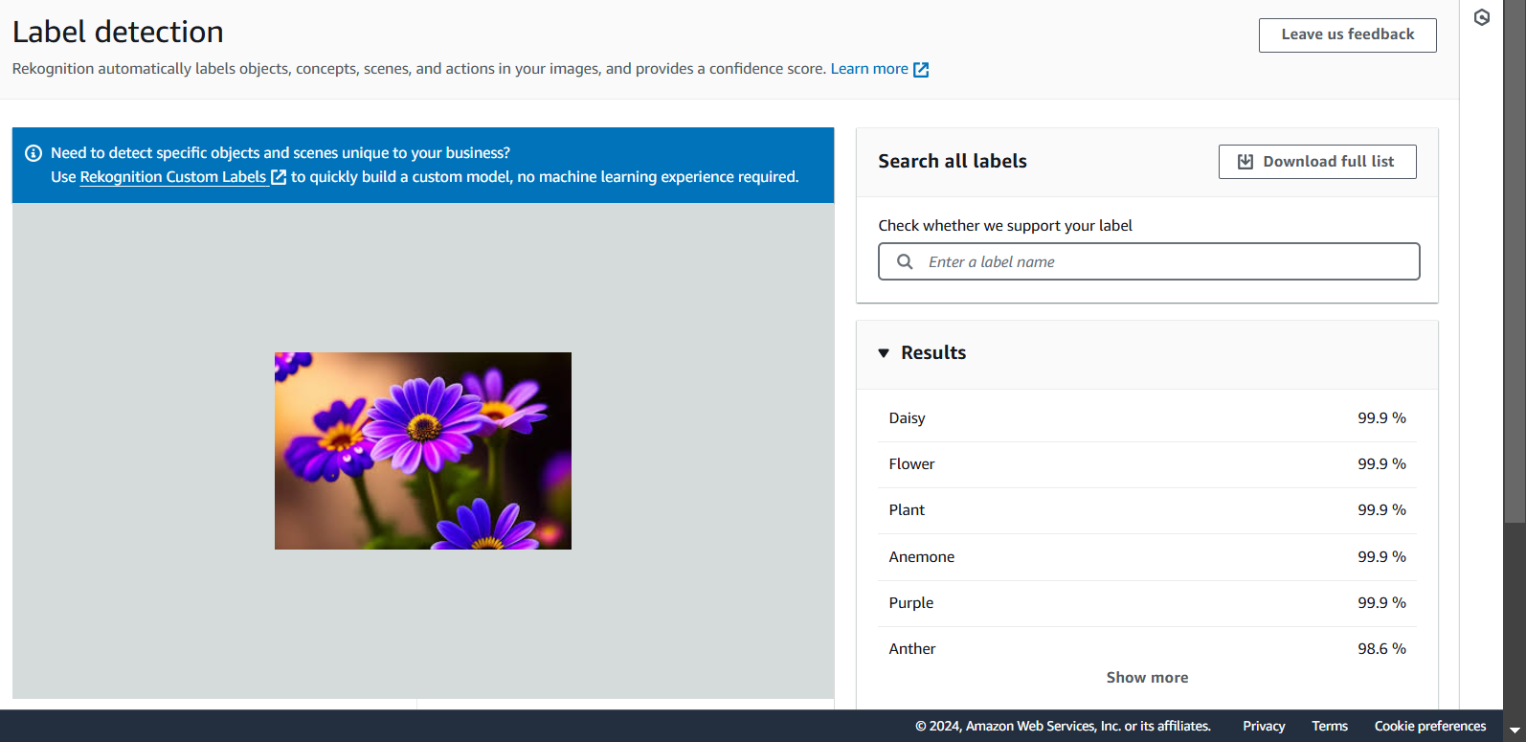

# 2. Image Properties

Amazon Rekognition provides information about image properties like dominant colors, image orientation, and more. This can be helpful in tasks like sorting and filtering images. .( upload or paste the link of image.)

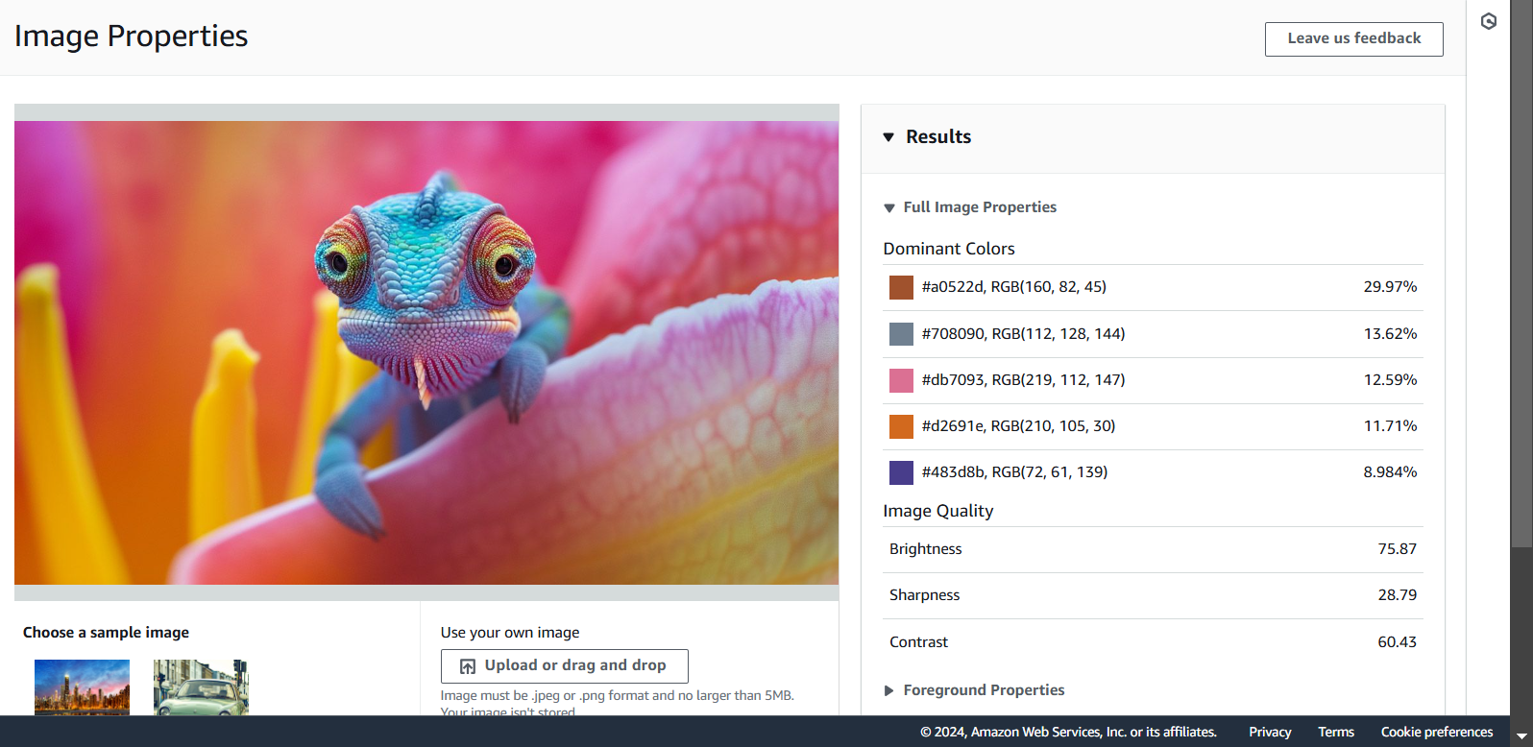

# 3. Image Moderation

Rekognition can detect inappropriate or offensive content in images and videos. It identifies explicit or suggestive content, helping businesses ensure that their content complies with standards. .( upload or paste the link of image.)

# 

# 4. Facial Analysis

Facial analysis allows Rekognition to detect attributes of human faces in images, such as age range, gender, emotions, and facial landmarks. It can be used for customer insights, security systems, or marketing purposes. .( upload or paste the link of image.)

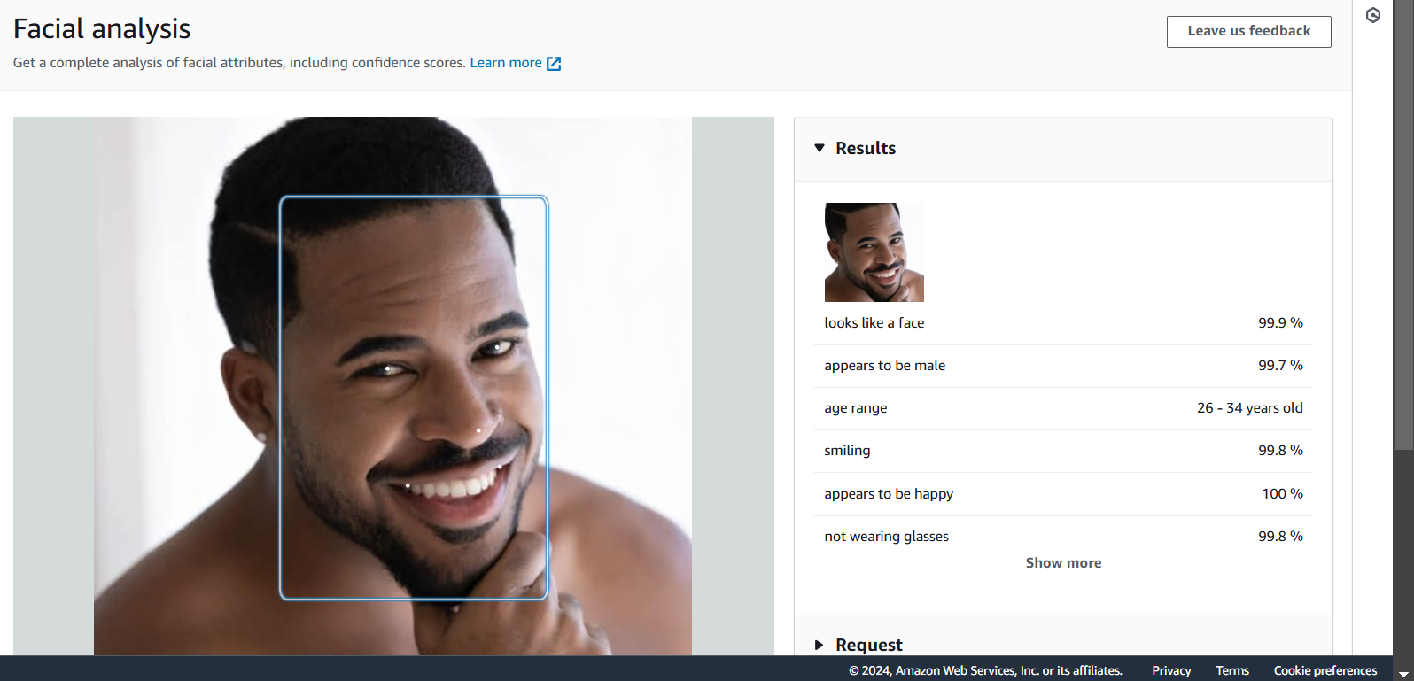

# 5. Face Comparison

Rekognition’s face comparison feature allows you to compare two faces and determine if they are the same or not. This is useful for applications like identity verification or access control. .( upload or paste the link of image.)

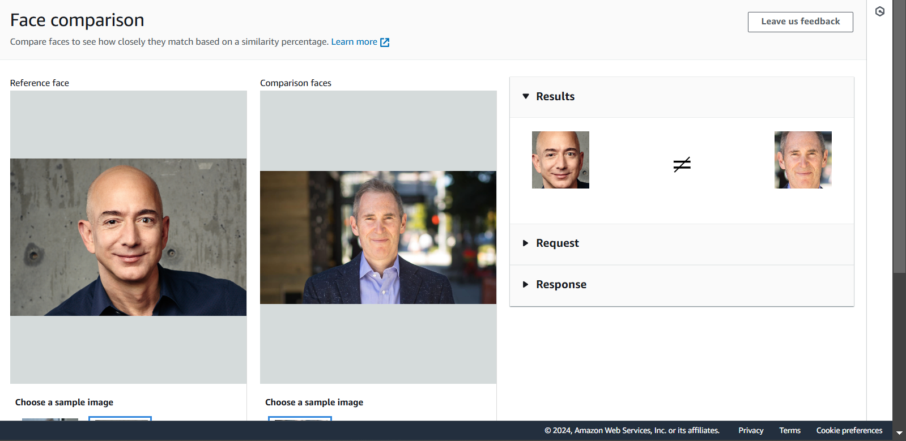

# 6. Celebrity Recognition

Amazon Rekognition’s celebrity recognition feature allows you to identify celebrities in images. This can be used for applications in media, security, or entertainment. ( upload or paste the link of image.)

